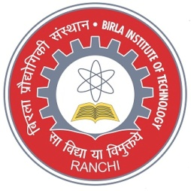
DEPARTMENT OF PRODUCTION ENGINEERING
BIRLA INSTITUTE OF TECHNOLOGY-MESRA, RANCHI
STUDENT’S ACHIEVEMENT
Shreya (BE/10211/15) won the “Mind Over Matter” annual innovation challenge organised by TATA STEEL. Shreya and her teammate won this competition and got Preplacement offer in TATA STEEL and 1 lakh rupees cash prize. The Problem Statement was to recover values from high ash coal using method of oil spillage recovery. | 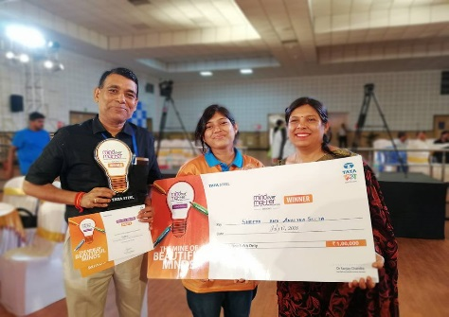
Aditya singh (BE/10664/16) got the first rank in the zone and was awarded with a cash prize of Rupees 21,000, a memento and certificate of Merit in the world skills competition organizied by the ministry of skill development and entrepreneurship, Govt. of India.

Jyoti (BE/10110/16) won the “TATA STEEL MIND OVER MATTER SPARK THE INNOVATION SEASON 6 (2019)” organized by TATA STEEL. Jyoti won this competition and got Preplacement offer in TATA STEEL and 1 lakh rupees cash prize. The Problem Statement was “Biodegradable surfactants for coal and iron ore beneficiation”. | 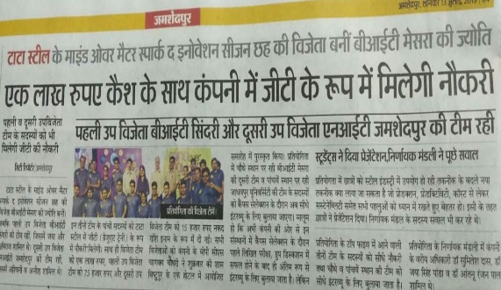
Aditya Kumar Lal (BE/10016/16) and Aditya Singh (BE/10664/16) secured first rank all over India in Deliotte Technoutsav CCTC 2019. They got a cash prize of 3.0 lakhs and Pre -Placement Offers in Deliotte US India. Around 15,000 students from 62 Engg. Colleges all over India participated in this competition. Out of Top 40 teams in nationals round they were only non-circuital team to participate and win the competition. | 